Systems Requirements Document (SRD) v1.0

Project Management

Project Number #
Project Name
CR #
Business Owner
Functional Area
Description

Change Management

IT Review
Role | Name | Revision # | Comments | Date | Initials
Technical Team Lead
Solutions Team Lead
ARB Team Lead
Project Mgmt Team Lead

Revision History
Date | Revision # | Author | Comments

Table of Contents
1. Introduction 3
2. Document the Non-Functional Features 4
2.1. Derive Non-Functional Features from the Architecture Principles & “ilities” 4
2.2. Identify opportunities to reuse existing Non-Functional Features 4
3. Update Requirements Traceability Matrix 4
3.1. Document the dependencies between Features 4
3.1.1. Functional Features & Non-Functional Features 4
4. Model the Business Processes 4
4.1. Rationalize the SIPOCS from the BRD 4
4.2. Identify changes to existing processes and/or new processes 4
4.3. Update the Process Models in ARIS 4
4.4. Conduct impact assessment for existing processes & Systems 4
4.5. Rationalize impacts on existing Process Models & Systems 4
5. Model the Data 4
5.1. Create Data Flow Diagrams (DFDs) 4
5.2. Identify changes to data structures (new data elements or changes) 4
5.3. Review Data Architecture changes with Data Governance Team 4
5.4. Update Enterprise Data Models in ARIS 4
5.5. Conduct impact assessment for existing Processes & Data Models 4
5.6. Rationalize impacts on existing Processes, Data Models & Systems 4
6. Capture the Business Rules & Constraints in ARIS 4
7. Document the Sequence Diagrams 5
7.1. Document the Interface Requirements 5
7.1.1. Triggers 5
7.1.2. Contracts between Modules / Systems (WSDLs if we’re using services) 5
7.1.3. Resiliency Requirements 5
7.1.4. Traceability Requirements 5
8. Document the Presentation Layer 5
8.1. Screen Profile 5
8.2. Configure Data: Fields and Functionality 6
8.3. Configuration GUI 6
8.4. Configure Rules & Constraints 6
8.5. Order Configuration Screen Fields and Functionality 6
8.6. Screen Mockup 9
9. Reporting & Analytics 9
9.1. Reporting Analysis 9
9.1.1. Identify the Reporting Objectives 9
9.1.2. Identify the KPIs that align with the reporting objectives 9
9.1.3. Derive the metrics required to align with the KPIs 9
9.2. Data Analysis for reporting needs 9
9.2.1. Data Elements 9
9.2.2. Data Sourcing & Extraction Parameters 9
9.2.2.1. Determine Data Warehousing needs 9
9.2.2.2. Determine if additional ODSs are required 9
9.2.3. Identify performance bottlenecks 9
9.2.4. Data Transformation Requirements 9
9.2.5. Data Masking & Releasability Rules 9
9.2.6. Document Aggregation & Reporting Analytics requirements 9
9.3. Report Layouts 9
9.4. Delivery Specifications 9
9.5. Archival Considerations 9

Introduction

The systems requirement document should translate the business requirements into engineering artifacts that can be consumed by software engineers for preparing their design documents. The first step is to review the Functional Features requested by the business and identify the Non-Functional Features we need to implement to support the Functional Features. This step requires input from a variety of SMEs on the technical side that have functional knowledge as well as a good understanding of the existing application landscape. They need to align the Non-Functional Features with the Functional Features and identify dependencies between all the features. Once the Requirements Traceability Matrix has been updated, they can focus on the modeling activities for processes, data and business rules.

The next set of sections focus on the integration planning, presentation layer setup and planning activities for delivering information back to the business. Here are the steps (ideally) followed for the SRD:

Step 1: Document the Non-Functional Features (driven from the Architecture Principles & “ilities”)
Step 2: Document the dependencies between Functional Features & Non-Functional Features
Step 3: Rationalize the SIPOCS from the BRD AND update the Process Models in ARIS
Step 4: Rationalize the Data Elements from the BRD AND update the Data Models in ARIS
Step 5: Rationalize the Business Rules & Constraints AND update ARIS
Step 6: Document the Sequence Diagrams to depict interaction between systems & modules
Step 7: Document the Presentation Layer (screen flow, screen layout, functionality & data dependencies)
Step 8: Document the Reporting & Analytics requirements

Development Methodology

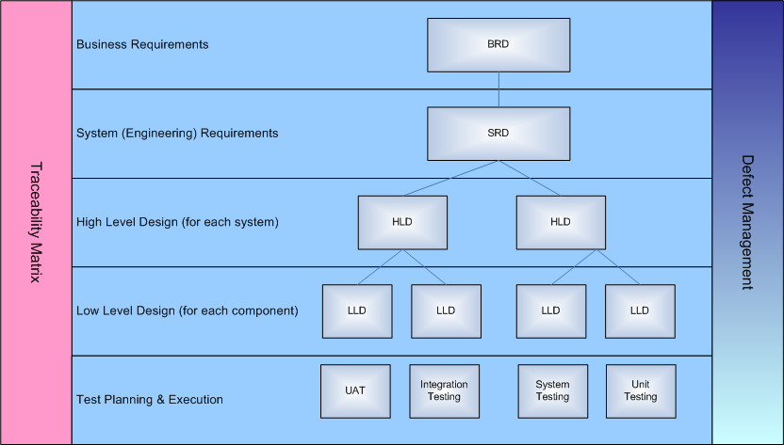

Document the Non-Functional Features

Derive Non-Functional Features from the Architecture Principles & “ilities”

Identify opportunities to reuse existing Non-Functional Features

Update Requirements Traceability Matrix

Document the dependencies between Features

Functional Features & Non-Functional Features

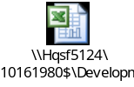

Model the Business Processes

Rationalize the SIPOCS from the BRD

Identify changes to existing processes and/or new processes

Update the Process Models in ARIS

Conduct impact assessment for existing processes & Systems

Rationalize impacts on existing Process Models & Systems

Model the Data

Create Data Flow Diagrams (DFDs)

Identify changes to data structures (new data elements or changes)

Review Data Architecture changes with Data Governance Team

Update Enterprise Data Models in ARIS

Conduct impact assessment for existing Processes & Data Models

Rationalize impacts on existing Processes, Data Models & Systems

Capture the Business Rules & Constraints in ARIS

Document the Sequence Diagrams
[Show the sequence of interfaces linked to events between systems and modules.]
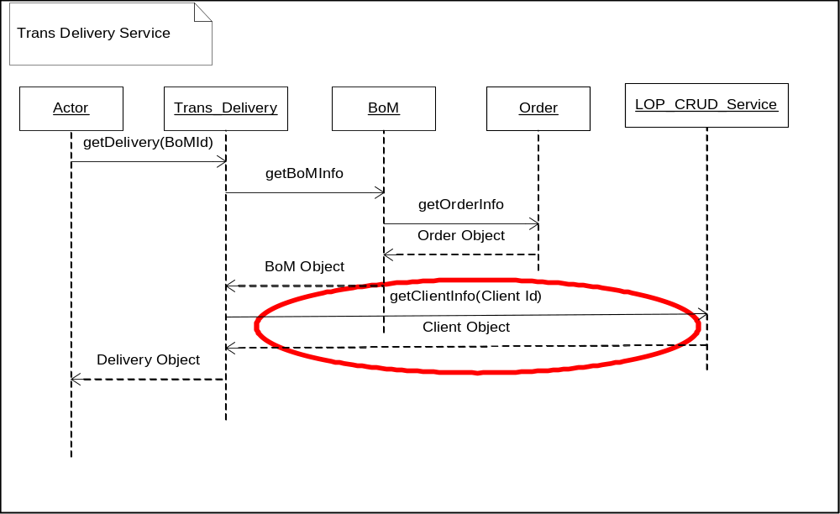

Document the Interface Requirements

Triggers

Contracts between Modules / Systems (WSDLs if we’re using services)

Resiliency Requirements

Traceability Requirements

Document the Presentation Layer
(screen flow, screen layout, functionality & data dependencies)

Screen Profile

Screen Profile
Screen Name | Order Configuration Screen
Screen ID | O02
Screen Purposes | Allows users to configure/reconfigure order dimensions based on the product model
Screen Functionality | - Allows users to configure/reconfigure order dimensions based on the product model  - Allows users to commit (save) configuration settings/updates  - Allows the user to abandon configuration settings/updates  - Provides for validation of configuration dimension settings based on the product model’s rules and constraints
Screen Accessible from | Screen ID | Conditions of Accessibility
Order Create Screen | O01 | When the user chooses the “Create Order” function
Order Detail Screen | O05 | When the user chooses the “Update Order” function for a particular order.
Screen Links to | Screen ID | Conditions of Accessibility
Standard Links | Standard Tabs | User clicks standard link button. Note: If the user has made changes to a configuration, a popup will be displayed with any standard key choice asking the user if he/she is sure that he/she wants to abandon their changes.
Order Detail Screen | O05 | If the user had been reconfiguring an order and the user completes the configuration activities and saves the configuration or if the user came from the Order Detail Screen and abandoned the configuration update
Order Create Screen | O01 | If the user was creating a new order and had come from the Order Create Screen and abandoned the Order Create operation.

Configure Data: Fields and Functionality

The Order Configuration Screen allows products to be configured based on the rules and constraints in the product model. A basic screen layout for the dimension classes and dimension items will be defined. The product model will define the behavior such as whether the dimension items are to be chosen as radio buttons, multi-select check boxes, drop downs, etc… The model will also define the constraints and rules that may prohibit particular selection combinations, enforce certain selections, or auto-select certain dimension items.

Configuration GUI

There will be two panes used in the configuration screen: the option item/option class pane and the configuration summary pane.

Configure Rules & Constraints

The Modeling System Design Document will address the product model including rules and constraints in more detail. The specific content of the option classes and the associated rules are beyond the scope of this document.

Order Configuration Screen Fields and Functionality

The fields and the functionality offered by the Configuration Screen which are not related to the product model are noted below.

Field ID / Type | Field Name | Description | Restrictions/Actions
O02-B1 | Save Configuration Button | Button which allows current Order Configuration to be saved | - Only displayed if the user is configuring/reconfiguring a draft order  - The current configuration items will be validated per the product model. If there are configuration errors, they will be displayed to the user in a pop-up box and the user will have the option of correcting the configuration or canceling his changes (i.e. not saving).  - If the configuration is valid, an “are you sure” popup will appear. If the user isn’t sure, the save operation will be aborted and the user will return to the configuration screen  - Conflict Handling: As noted above in the conflict handling section, If the order has been modified by someone else since it was bought up, a popup will be displayed to the user noting that someone modified the configuration. When the user clicks on a continue button on the dialog, the configuration will be reread and redisplayed.  - The current configuration will be saved and the Order Detail Screen will be displayed showing the updated configuration information.
O02-B2 | Commit Order Button | Button which allows current order configuration to be saved (updated) | - Only displayed if the user is updating (reconfiguring) an order  - The current configuration items will be validated per the product model. If there are configuration errors, they will be displayed to the user in a pop-up box and the user will have the option of correcting the configuration or canceling his changes (i.e. not saving).  - If the configuration is valid, an “are you sure that you want to update this order” popup will appear. If the user wasn’t sure he will return to the configuration screen and the save operation will be aborted. If the user was sure:  - A popup will appear which allows the user to enter a comment for the order  - This field must be filled in for updated orders and fill-in is optional for newly committed orders  - Standard special character filtering rules apply  - The user will have the ability to abort the save operation from this popup  - Conflict Handling: As noted above in the conflict handling section, the timestamp of the configuration and order will be reread before the save. If it had changed, a popup will be displayed to the user noting that someone modified the configuration. When the user clicks on a continue button on the dialog, the configuration will be reread and redisplayed. If the configuration’s status had changed to committed or had been cancelled, the screen will be updated appropriately.  - The updated order will be saved as a new version (copy) of the order will be saved with the new updated configuration information
O02-B2 | Cancel Button | The name of the order line item that was given by the user when creating the order | - An “are you sure” popup will appear. If the user is sure, his changes will be abandoned, and he will return to the Order List Screen.
O02-B3 | Verify Button | Allows a configuration to be verified for completeness and correctness based on the product model | - Performs checks based on the model which are a function of completeness or intra-option class/item rules

Screen Mockup

Insert a mockup of the Screen to present an early view of the layout of GUI objects & data elements.

Reporting & Analytics

Reporting Analysis

Identify the Reporting Objectives

Identify the KPIs that align with the reporting objectives

Derive the metrics required to align with the KPIs
Metrics should be derivative from KPIs per the Metrics Model for the business

Data Analysis for reporting needs

Data Elements

Data Sourcing & Extraction Parameters

Determine Data Warehousing needs

Determine if additional ODSs are required

Identify performance bottlenecks

Data Transformation Requirements

Data Masking & Releasability Rules

Document Aggregation & Reporting Analytics requirements
Leverage existing analytics where possible

Measure # | Measure Type | Measure Name | Measure Detail
[AN0001] | Base | Avg Unit Sales per Month | Total Units Sold / # Months
[AN0002] | Combo | Category Weighted Distribution | Total Units Sold for Category / Total Units Sold for all Categories

Report Layouts

Delivery Specifications
Batch, Ad-Hoc / Real-Time, Availability

Archival Considerations

